Bill2Pay 1099K

Deployment Guide

Date: 3/1/2017

**Statement of Confidentiality**

*The information contained herein shall not be disclosed, duplicated, or used in whole or in part for any purpose other than to evaluate the proposal, provided that if a contract is awarded to this offer as a result of, or in connection with, the submission of these information, the recipient shall have the right to duplicate, use or disclose the information to the extent provided in the agreement. This restriction does not limit the right to use information contained in the data if it is obtained from another source without restriction.*

**© 2016 RS Software (India) Ltd.**

Table of Contents

Abbreviations 4

Revision History 4

Approvals 4

Introduction 5

Deployment Guide 6

Database Creation 6

Database Schema Execution and Master Data Creation 7

Application Deployment in IIS 8

Testing Deployment 13

# Abbreviations

|  |  |
| --- | --- |
| RS | RS Software |
| TIN | Taxpayer Identification Number |
| IIS | Internet Information Server |

# Revision History

|  |  |  |
| --- | --- | --- |
| Date | Version Number | Change Description |
| 03/01/2017 | 1.0 | Initial Version |

# Approvals

|  |  |  |  |
| --- | --- | --- | --- |
| Role | Name | Title | Date |
|  |  |  |  |

# Introduction

This document captures the deployment details for the 1099-K development project undertaken by RS Software for Bill2Pay.

# Deployment Guide

Extract Provided ZIP files in a desired location, the file structure looks as follows:   
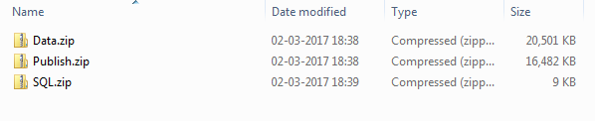Deployment procedure contains following sections

* 1. Database Creation
  2. Database Schema execution and Master Data Creation
  3. Application Deployment in IIS
  4. Testing Deployment

# Database Creation

1. Open SQL Query analyzer and authenticate to Server
2. Create a new database from the navigation menu. This database will be used by the application.  
   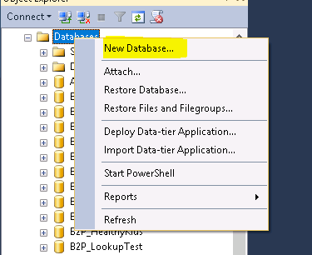

# Database Schema Execution and Master Data Creation

1. Extract SQL.zip into desired location. The zip file contains the script file “Bill2Pay_K1099_DB.sql”
2. Execute the script “Bill2Pay_K1099_DB.sql” in SQL Query Analyzer under the newly created database
3. This will perform the following task.
   1. Create Table/View/Procedure for the application
   2. Insert master data into following table
      1. User
      2. Role
      3. Merchants
      4. Payer
      5. Transmitter

# Application Deployment in IIS

Prerequisite:

1. IIS Management Console
2. .NET Framework 4.5
3. Network Connectivity with DB Server and IIS Server
4. Extract “Publish.zip” file in a desired location. Following are the contents of the zip file:  
   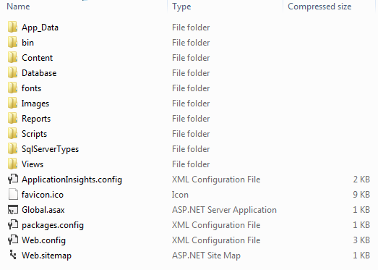
5. Open IIS Management Console in Windows explorer by running the command “inetmgr” from Start > Run.

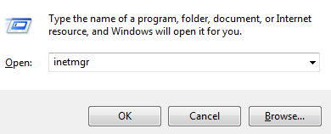

Note: User may require extra privileges to open IIS Console

1. Verify Dot Net Framework 4.0 is configured in the Default Application Pool. A separate application pool for the application can also be created. Ensure that the new application pool is configured with Dot Net Framework 4.0.

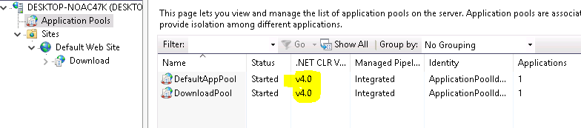

1. Create IIS Application using the navigation menu

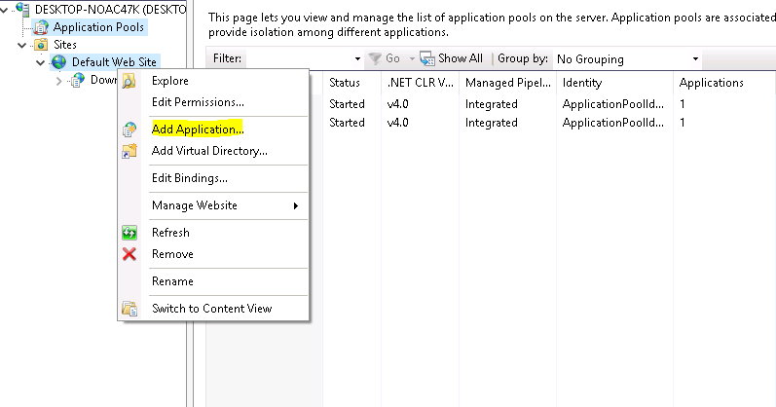

Right Click over Default Web Site, and “Add Application”

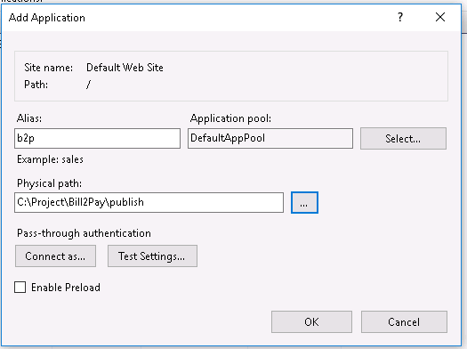

Provide necessary information.

1. Alias: [USER DEFINED NAME]
2. Application Pool: 4.0 Integrated
3. Physical File Path: Physical folder location of the application.
4. Verify Database Connection Settings

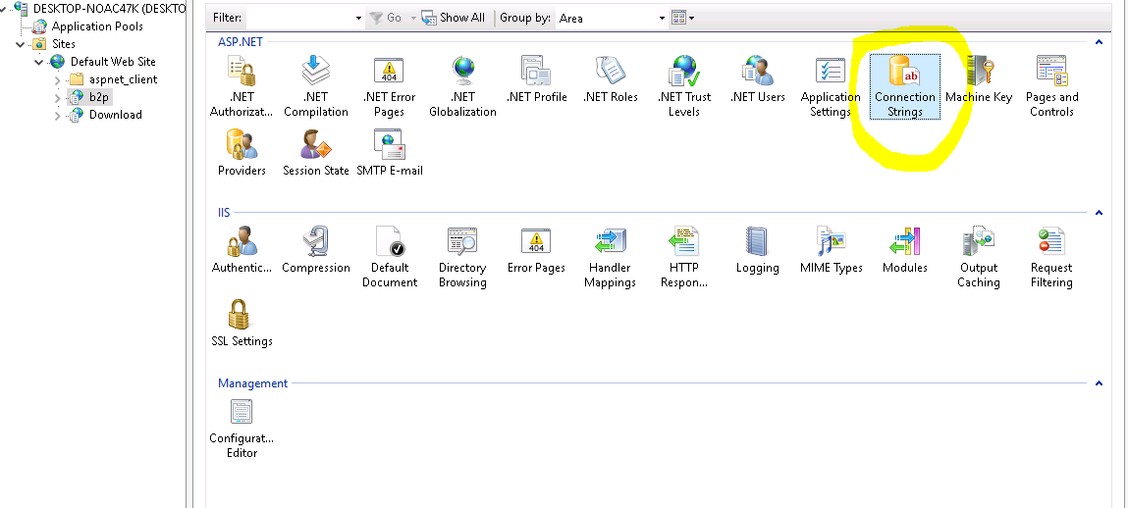

1. Change Database Connection accordingly

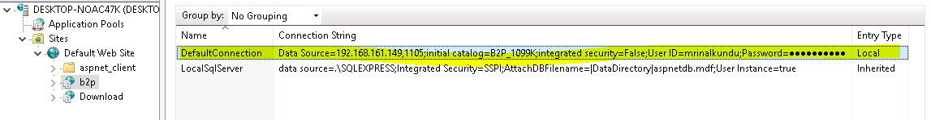

1. Enable Forms Authentication

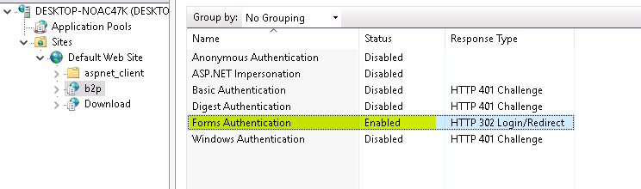

# Testing Deployment

1. Open the URL in browser. It will prompt for the Login credentails.  
   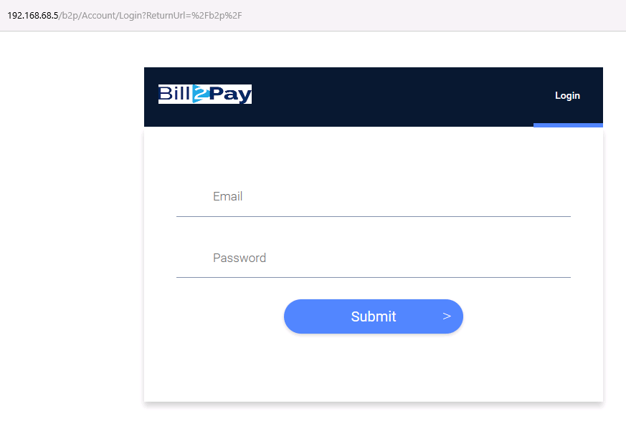
2. Initially two default role is mapped with the application
   1. Admin
   2. User
3. Two Users are pre-configured to be allowed to login to the System with corresponding Role
   1. User: [admin@b2p.com](mailto:admin@b2p.com) , Password: Admin@123
   2. User: [user@b2p.com](mailto:user@b2p.com), Password: User@123
4. User will be prompted to change password after the first successful login.  
   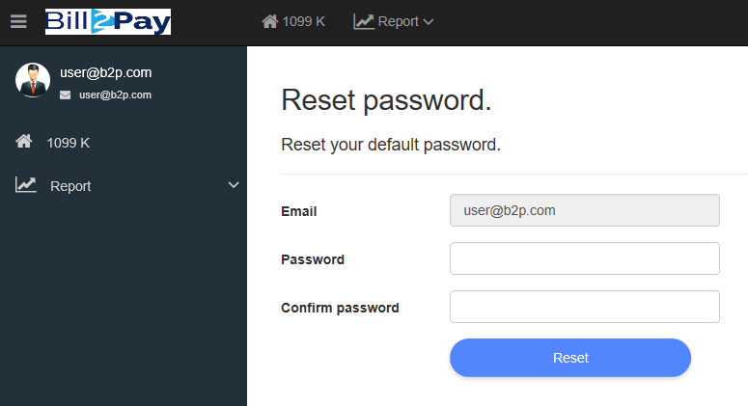
5. Import Transaction from the application navigation menu Import -> Import Transaction.
6. Extract “Data.zip” from the deployment package in a desired location. Following are the contents of the zip file:  
   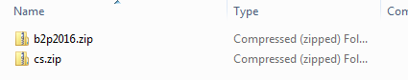
7. Import the zip files into the application. Note: Only the role “Admin” is allowed to perform the operation  
   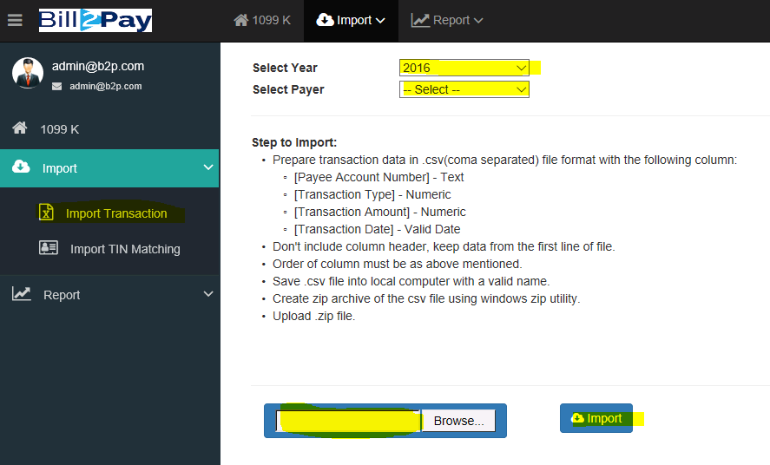
8. After successful Import, list of merchants will show up in the “1099 K” link.  
   